**Ultimate altimeter**

**Operating instructions**

|  |  |
| --- | --- |
|  |  |

|  |  |  |  |
| --- | --- | --- | --- |
| **Version** | **date** | **Author** | **Comments** |
| 1.0 | 04/01/2025 | Boris du Reau | Initial version |
|  |  |  |  |
|  |  |  |  |

**Rocket Type**

|  |  |  |  |  |
| --- | --- | --- | --- | --- |
| **Micro-max** | **Model Rocket** | **Mid power** | **High power** | **Water rocket** |
| No | yes | yes | yes | yes |

**Category**

|  |  |  |  |
| --- | --- | --- | --- |
| **Construction technic** | **Ground Support** | **Electronic** | **Other** |
|  |  | **X** | X |

Goal 3

Related documentation 3

About the altimeter 4

Flashing the altimeter firmware 4

Choosing the power supply 7

Preparing the altimeter 7

Powering off the altimeter 8

Installing the altimeter in the Rocket 8

Using the altimeter 8

Reading your altimeter data without an Android device 8

Reading your altimeter data with an Android device 9

Using a USB cable 10

Altimeter box 14

Testing the altimeter on the ground 14

Contributing to the board development 14

Trouble shooting 15

# Goal

The goal of this document is to explain how to use the Ultimate altimeter that you just bought. The document assumes that you have already installed altimeters in a rocket payload bay.

Before your start

***Remember that you can modify the program and behaviour of your altimeter.***

***The country where you live might not even allow the use of such device. You have to assume total legal responsibility for any damages or claims including personal injury that results from the use of this device. I shall not be responsible for the above. If you disagree with that, please do not build it or use it.***

# Related documentation

This document assumes that you have red the Bear Altimeters console documentation. This document will show you how to use the altimeter stand alone or with the console to view flights on a larger screen. I will also cover things such as flashing the altimeter from the Android Console.

# About the altimeter

The altimeter is made using a **TS-ESP32-S3** board which contains an **ESP32S3** micro controller from **Espressif** no additional custom board is required because the board already has a BME280 barometer and a QMI8658 sensor (accelerometer + gyroscope. The flights can be stored on the board no need of an additional EEPROM.

The firmware is written in C/C++ using the Arduino environment you can download the latest firmware from github

<https://github.com/bdureau/UltimateAltimeter>

If you are a developer you can build the firmware yourself using the Arduino environment and upload it to your board. Detailed instructions to build the code are available on the Github repository.

# Flashing the altimeter firmware

The altimeter firmware can be flashed using the “**BearConsole**” application available on the Android playstore.

<https://play.google.com/store/apps/details?id=com.altimeter.bdureau.bearconsole>

Currently no application is available for Apple and I am not planning on doing any. Should any one want to write one the Android source code is available on my Github

<https://github.com/bdureau/BearConsole2>

You will need to get a USBC cable

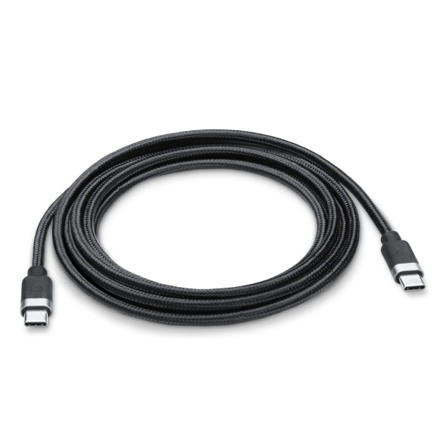

*Note that when flashing the altimeter no need to configure the application to use USB, it will automatically do it because a USB cable is the only way to flash the altimeter, you cannot do it with a Bluetooth module.*

The following needs to be done to flash your board with a new firmware

* First install the application on an android device. Get it from the Android playstore <https://play.google.com/store/apps/details?id=com.altimeter.bdureau.bearconsole>
* Get a USB cable and connect your phone to the altimeter

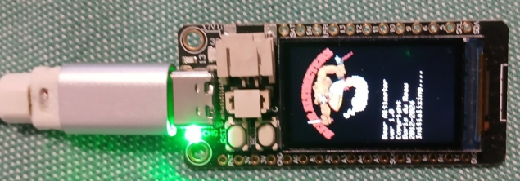

* Open up the BearConsole application

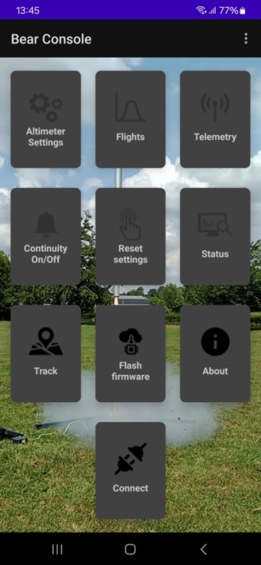

* Tap on the flash firmware button

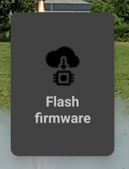

* Grant the permission

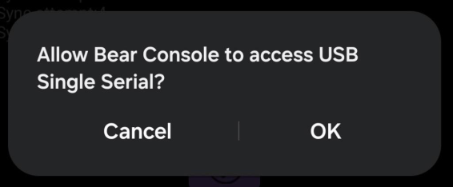

* Select your altimeter firmware. Make sure that you choose the appropriate firmware, if you don’t you will have unexpected behaviour.

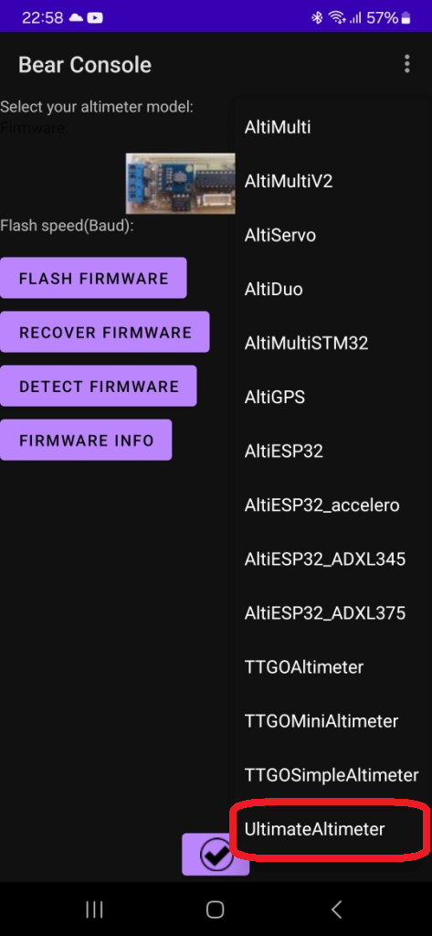

* Tap on the flash firmware button

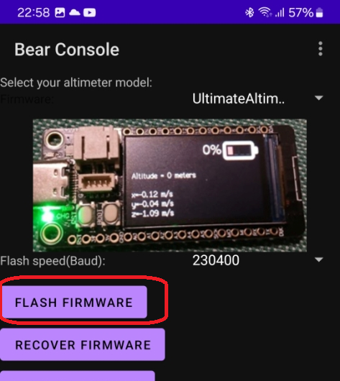

A popup will display with the firmware progress

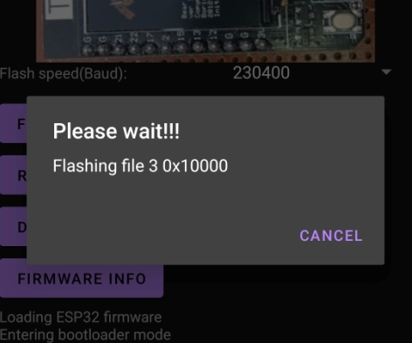

Flashing should take less than a minute when complete reset your altimeter.

*Note that you need to make sure that the cable is connected during the entire upload of the firmware.*

# Choosing the power supply

The kit has been designed to use a 1S (3.7 Volts) battery. Using a poor quality battery may result in altimeter malfunction. You will need to get a JST plug compatible with your board or you can solder your 1S battery directly on the board (**red** wire on **Vbat** and **black** wire on **GND**). Be careful the **TS-ESP32-S3** board JST plug is wired reverse; if you use a standard battery with a JST plug you will burn your board.

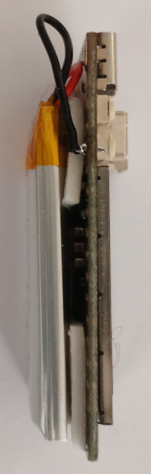 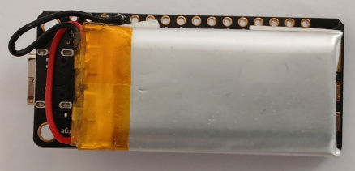 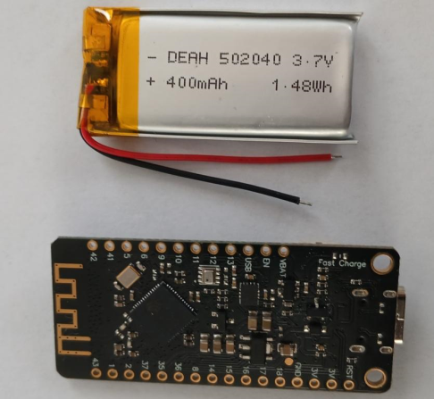

**Charging the altimeter**

The altimeter can be charged using a USBC cable and any USB port from a computer or from a USB charger. You will see the charge progress with the battery symbol.

# Preparing the altimeter

When using the altimeter for the first time the altimeter **must be initialized**. First you need to blank the eeprom.

Power the altimeter by pressing **button 2**.

Then press **button 2** for more than 10 seconds.

This will **erase all flights**.

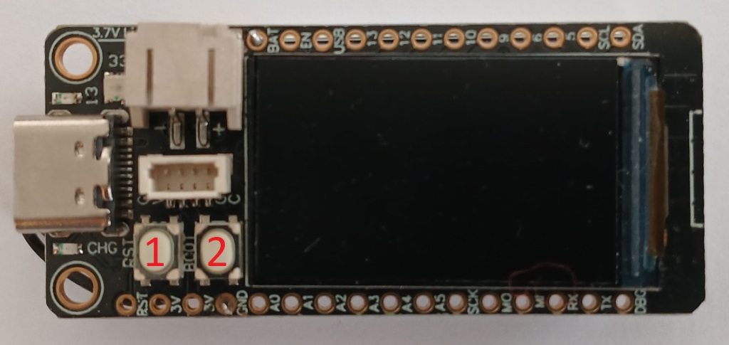

You are now left with an altimeter with no flights at all ready to be used.

Note that if you do not initialise your altimeter you may not be able to start recording flights.

Note that **button 1** is the reset button; everything is done using only **button 2**.

# Powering off the altimeter

You do not turn off your altimeter using a switch. By pressing **button2** for more than 5 seconds you can put the altimeter in hibernate mode. Because it is in hibernate mode you need to make sure that you recharge your altimeter at least once a month otherwise your battery will get discharged under 3 volts and could be permanently damaged.

If you do not want to charge your altimeter, unplug your battery.

# Installing the altimeter in the Rocket

The altimeter is very easy to install, just attach it to the nose cone. You will need to make sure that you have one or more vent holes to allow pressure exchanges.

Make sure that the electronic is protected from ejection smokes which are very corrosives and could damage the altimeter board very quickly.

However remember that you have a pressure sensor which needs to measure pressure changes to work out altitude changes… hence you need to drill a hole in your payload bay.

# Using the altimeter

Now that you have everything installed in your rocket you can turn it on. The altimeter wait until lift off is detected. Lift off being by default reference altitude + 20 meters (this can be changed). Make sure that the altimeter is fully charged so that it can record the entire flight.

# Reading your altimeter data without an Android device

You can read your data directly on the altimeter screen. The altimeter has been designed so that it can be used without an Android device; this will have limited functionalities but will allow you to quickly see your flight data when on the field.

**Retrieving your flight data**

Press **button 2** for more than 2 seconds will display the first flight. By default the altitude curve is shown.

To navigate between the flights curves short press **button 2**

The following data are available:

|  |  |
| --- | --- |
| Altitude | Pressure |
| Acceleration on 3 axis    Humidity | Temperature |
|  |  |

To exit the flight mode press **button 2** for 2 seconds.

**Erasing flight data**

To prevent altimeter memory filling up you will have to erase your flights especially if those take a long time.

To clear all the flight press **button 2** for more than 10 seconds

# Reading your altimeter data with an Android device

If you have an Android device such as a tablet or a phone you can take the advantage of a bigger screen to see your flight data. This will also allow you to export them and share them with friends.

Application can be downloaded for the store

<https://github.com/bdureau/BearConsole2>

The altimeter uses a USB cable to communicate with any Android device.

Open the **BearConsole** application configuration to configure it to use USB rather than Bluetooth.

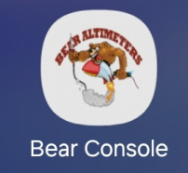

## Using a USB cable

Connect your altimeter to your Android device using a USBC cable. Make sure that you configure your application so that it uses USB rather than Bluetooth and that option “Full usb support” is ticked. Lastly the baud rate should be 38400.

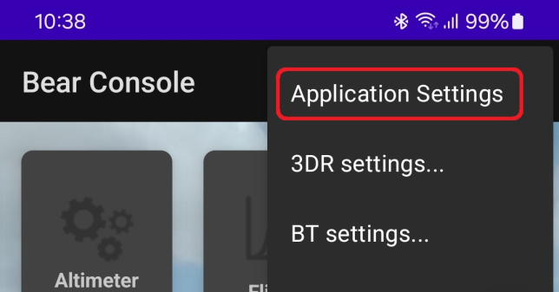 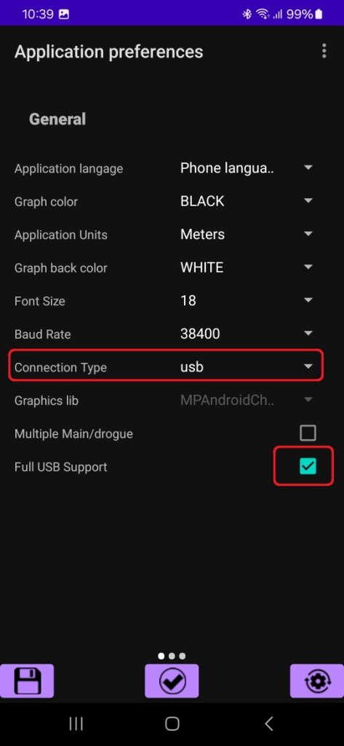

Then tap on save.

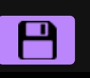

**Connecting**

On the main screen tap the connect button,

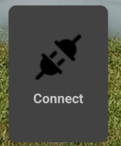

When connected the connect button will change its name to disconnect.

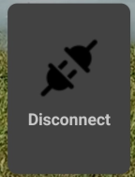

You can now using the applications functionalities that are available for the Ultimate altimeter.

**Retrieving your flight data**

Tap the flights button;

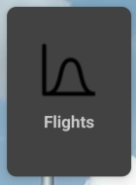

this will retrieve all your flights.

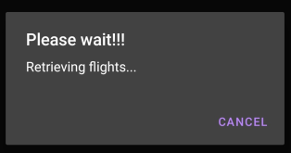

The select which flight you want to see.

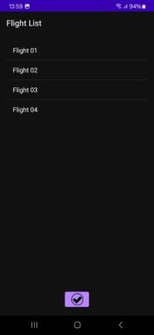

When in the flight you can select which curve you want to see.

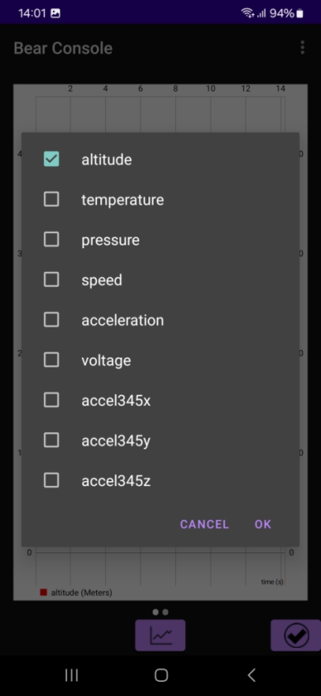

If you slide from right to left this will take you to the flight summary data

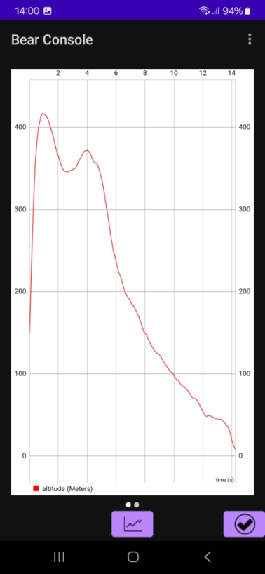 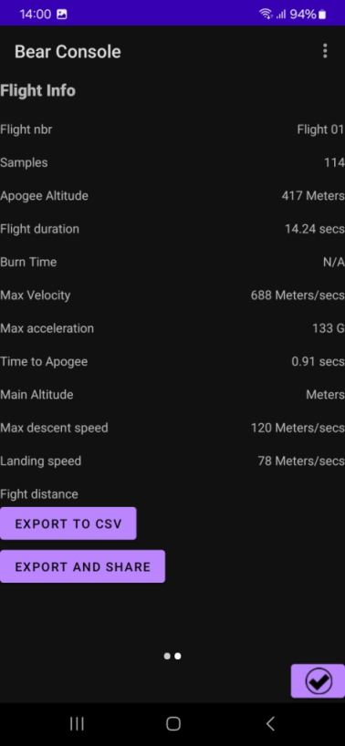

On any of the flight screen you can share the data using Whatsapp or email. You can share pictures of your flight as well as CSV data.

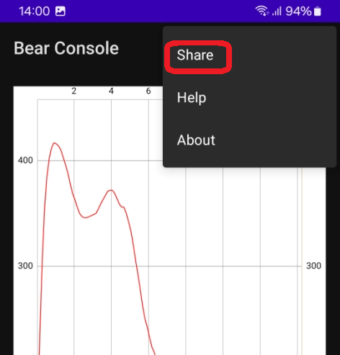 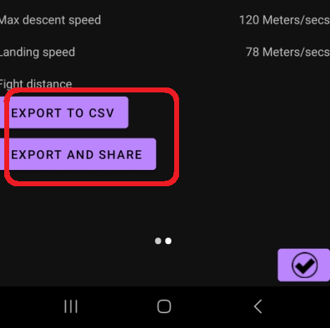

**Erasing your flight data**

To prevent your altimeter memory to be full which will stop you from recording new flights you need to erase your flight data. Space available on the board depends on the flight duration that you have recorded so far.

To erase flight data tap the “Reset settings” button

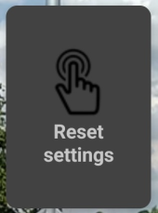

Then tap the “Clear Flights” button to erase all flights

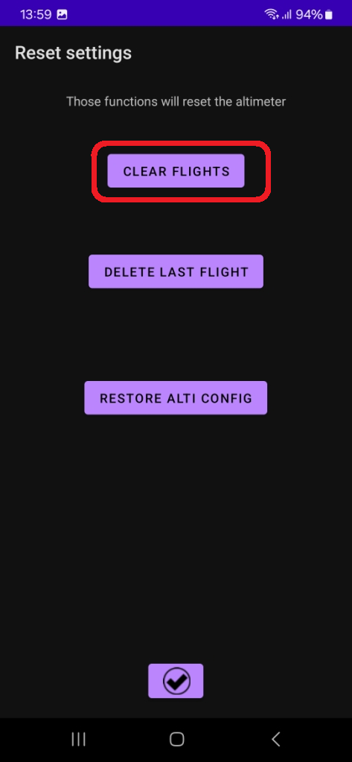

Please refer to the on line help accessible from the console help menu. On some screens tool tips have been added to the screens to explain what it does. Currently the application is available in English French, Spanish, Italian, Portuguese, Russian, Dutch…. Should you want it in your own language I can provide a file with strings that can be translated and I will update the application with your own translations.

You can also refer to the Console documentation but it might not be up to date.

# Altimeter box

A box to protect the altimeter that can be 3D printed has been designed with OpenScad and is available for download.

<https://github.com/bdureau/UltimateAltimeter/tree/main/3Dcase>

# Testing the altimeter on the ground

In order to test all the firing sequences, I suggest that you build a very basic pressure chamber. It will cost you a couple of dollar and you will make sure that your altimeter is working before you fly your rocket.

Reading the data

Should you need additional help do not hesitate to ask, my contact details are on

<http://rocket.payload.free.fr/>

or you can send me an email

[boris.dureau@neuf.fr](mailto:boris.dureau@neuf.fr)

# Contributing to the board development

You do not have to be a developer to help on the project. Reporting bugs helps a lot to improve the altimeter. Interface suggestions will also improve the user experience when navigating. If you are good at making nice graphics this could also improve the look and feel of the application. If you have good writing skills you can help by contributing to the documentation.

Finally to allow people around the world to use the application in their own language you can help translating the application or documentation.

# Trouble shooting

Because you have the ability to configure quite a lot of things on you altimeter things can go wrong and you might not be able to connect to your altimeter anymore…..

Do not worry; it is possible to reset the configuration of your altimeter.

**Scenario 1:** able to connect to the altimeter but the unable to modify the altimeter config without crashing the application

**Solution:**

Connect to the altimeter using the console (Bluetooth or cable) and reset the altimeter config to the default one.

**Scenario 2:** able to connect to the altimeter but the unable to load the flights without crashing the app.

**Solution 1:** You might be using Android version 8 or greater so you need to use a different graphic library. Go to the “Application Settings” menu and change the graphics lib to MPAndroidChart and click save.

**Solution 2:** You have probably stored flights with an older version of the firmware so you are unable to read them. You need to delete them all. In order to do that click on the “RESET SETTINGS” button and delete all flights.

**Scenario 3:** unable to connect to the altimeter

**Solution 1:** It could be because you have changed the altimeter baudrate and it is not matching the Bluetooth module baud rate anymore. You can try to connect using a cable and change the baudrate of the cable until you find the correct baud rate. Then you change the baud rate to 38400 and save the config. Alternatively you can reset the config.

**Scenario 4:** after upgrading the console the altimeter does not connect

**Solution 1:** you might need to flash the firmware from the console in order to make sure that your altimeter and firmware are in sync.

**Scenario 5:** unable to flash the altimeter

**Solution**: you might need to put the altimeter in boot mode before pressing the FLASH FIRMWARE button.

**Scenario 6:** Altimeter behaviour is not has expected

**Solution 1**: maybe the firmware is incorrect, reflash it was the correct one

**Solution 2:** rest the config to the default one

**Scenario 7:** cannot connect to the altimeter using Bluetooth

**Solution 1:** make sure that the connection type is Bluetooth

**Solution 2:** make sure that you have selected the correct Bluetooth module.

**Scenario 8:** cannot connect to the altimeter using the TTL cable

**Solution 1:** make sure that you have selected USB from the “Application settings” menu and that the seep is 38400 (unless you have changed it to something else).

If you experience any other issues that are not listed please contact me for advices. You will need to provide the following information:

* Altimeter model
* Firmware version
* Android version
* Console version